College Avenue Presbyterian Church

5951 College Avenue | Oakland | 94618
www.capcoakland.org | www.capcoakland.me

Office : 510.658.3665 | capc1@sbcglobal.net

Pastor Monte: 510.658.3666 | Cell 510.520.0746
montemcclain@gmail.com

Welcome to CAPC Oakland!

We are a reformed, multicultural, politically purple, community of followers of Jesus seeking to live our faith seriously in word, deed and relationships in the East Bay.

If you’ve never celebrated with us, you can follow along using this paper or the projection on the screen. Hymnals and Bibles are in the pews. We invite you to join us for a moment of community connection afterwards with a
drink and simple snack.

CHILDREN

We have a quiet play area for children in the front of the sanctuary with toys and coloring sheets that can be played with during services. We also have a lounge, off the entryway, where the service is broadcast if you need more space.

We invite children 3 years old to 6th grade to depart for Godly Play following our second song. You can gather your child(ren) after worship upstairs in the GP room.

PRAYER CARDS

You’re invited to share your prayers of concern or gratitude by filling out the cards, located in the pews, and placing them in the glass vase on the table. We’ll use them during today’s service.

WIFI & SOCIAL MEDIA

2wire927 is our open wifi. The password is 7304088568. If you do social media during the service we invite you to add #capcoakland to include others.

NESTLÉ PARKING LOT

We’re able to park in the lot behind the church. They ask us to enter and exit off of Chabot Road, using the pedestrian door there near Crossroads Trading.

CCL #1137062
August 5, 2018

GATHERING SONG “Womb Of Life” - Insert

CALL TO WORSHIP

SONG OF PRAISE “I Was There to Hear Your Borning Cry” - Insert

ACT OF CONFESSION. opening ourselves to being undone, that we might be redone

SUNG PRAYER OF REPENTANCE “Ancient Words” - Insert

DECLARATION OF GRACE. the in-breaking of god’s grace disrupts our human condition of sin

PRAYERS OF THE PEOPLE & THE LORD’S PRAYER

Call and response liturgically prayed at the conclusion of sharing a prayer card

Leader: God, in your mercy.

People: Hear our prayer.

To pray with someone after the service, look for today’s liturgist after today’s service

GIVING OF OUR TITHES & OFFERINGS TO EMPOWER THE WORK OF GOD IN THE CHURCH

OFFERTORY SONG “Morning Has Broken” - Blue Hymnal #469, 1-2

LISTENING FOR GOD’S WORD

READING OF SCRIPTURE - Patt Schroeder
Psalm 139 Pew Bible, p. 609

TESTIMONY SERMON - Myrna Shadley

RESPONDING TO GOD’S WORD

SONG OF RESPONSE “Spirit, Spirit of Gentleness” - Blue Hymnal #319

COMMUNION: STRENGTH FOR THE JOURNEY OF FAITH
We celebrate by intinction, coming forward to receive the meal. If you’d prefer an individual cup or to be served at your seat, please raise your hand during our celebration as we’ll attend to you.

SONG DURING COMMUNION “Let Us Break Bread Together” - Blue Hymnal #513

ANNOUNCEMENTS

SENDING CALL AND RESPONSE

Leader: God is good! Leader: And all the time!

People: All the time! People: God is good!

EXHORTATION & BENEDICTION

PASSING THE PEACE OF GOD “Kedamaian Kristus” - Indonesian

We pass the peace weekly using languages native to the cultures of our church community
as an audible sign of the Dominion of God at work towards the healing transformation of the world.
Thoughts on Today’s Scripture
ANNOUNCEMENTS & COMMUNITY NEWS

August Birthdays

5 Lori Castner Amber Beatty (2011)
8 Anne Marie Adams 12 Sharon Nelson 12 David Kittams 22 Patrice Trowbridge 24 Bob Brylawski 25 Margaret Smith
August Anniversaries

5 Jeff and Linda Trowbridge 1978
8 Bob and Ellen Brylawski 1987
9 Thom and Tina Faulkner 2002
30 Monte and Kristy McClain 1997

Community Calendar

Youth Group today 7-8:30pm | VBS Counselor training!

Teaching ESL Classes, tomorrow, Monday, August 6th 7-9pm at Primera Iglesia 1940 High St 94601.

Choir Practice | Tuesday, 5:30-6:30pm (Sanctuary)

The Vocabulary of Faith | Sundays 9:30-10:15am

Friday Night Meal | Our next meal is 8/24 6-7pm |

Congregational Meeting | Today, after worship regarding pastoral terms of call.

BLESSING OF THE BACKPACKS| Next Sunday August 12th in worship. Bring your backpack or some other sign of being a student or work in education as we celebrate the new school year.

Help Monte make lanyards between now and then to distribute to our students as an icon-blessing!

Letter Ministry | Encourage another with a hand-written note. They’re ready to go on the back wall!

All Church Retreat – with First Pres Alameda! | September 7-9, 2018 | Register on paper or online @ www.capcoakland.org/church-retreat.

Recreation VBS | This week ! - August 6-12, 9a-3pm | for all church kids & others! | You can also volunteer to help! Info @ www.recreationvbs.org

COME TO THE VBS ART SHOW – Thursday, 7-8pm

Thank You to Our Leadership This Morning!
Reader: Patt Schroeder
Testimony: Myrna Shadley
Fellowship: Margaret Smith
No Godly Play as we’re having communion!

Leadership for next week, 8/12/18:
Fellowship: Bob & Ellen Brylawski
Godly Play: David Kittams [ST]; Maya Patil [DK]

Psalm 139

Psalm 139 is classified as an Individual Hymn of Thanksgiving. In this genre, singers praise God for God's goodness in delivering them from various life-threatening situations, such as illness, oppression, enemy attack, etc. Here, the psalmist celebrates the creative goodness of God in verses 1-18, and provides a glimpse of the oppression that occasioned the composition of the psalm in verses 19-22. It concludes with a plea to God to search for any ill-feelings towards others, presumably those who have so hurtfully oppressed the poet.

Throughout this testimony, the psalmist addresses God directly, using the personal name of Israel's God, Yahweh (1, 4). Second person pronouns (you…) occur ten times in the first six verses.
With this abundance of first and second person pronouns, the psalm-poem reflects the profound relationship of the "I" and "You" (or, "I" and "Thou") in ancient Israel. Walter Brueggemann describes this relationship by saying, "The Psalms are prayers addressed to a known, named, identifiable You. This is the most stunning and decisive factor in the prayers of the Psalter." In a book titled Tales of the Hasadim, Martin Buber, an early twentieth-century Jewish philosopher, offered these words concerning the relationship between God and humankind:

Where I wander - You!
Where I ponder - You!
Only You, You again, always You!
You! You! You!
When I am gladdened - You!
When I am saddened - You!
Only You, You again, always You!
You! You! You!
Sky is You, Earth is You!
You above! You below!
In every trend, at every end,
Only You, You again, always You!
You! You! You!

The close relationship between the psalmist and God is not only emphasized in the language of "I" and "thou" in Psalm 139, but also in the repetition of the verbal root yada' (to know), which occurs seven times (1, 2, 4, 6, 14, and twice in 23). Yada' is a rich word in biblical Hebrew, covering a whole range of meanings - from simple recognition to intimate sexual relationship. We are to know God, just as God knows us. As the psalmist says, "It was you who formed my inward parts; you knit me together in my mother's womb". (This is a redacted portion of the article on Psalm 139 written by Prof. Nancy de Claissé-Walford that you can find online at www.workingpreacher.org/preaching.aspx?commentary_id=226)

Questions for the practice of Examen & Contemplation
- What grabs your attention in this reading?
- How has knowledge of God, and being known by God, surprised you? Blessed you? How does it invite you to be?
LYRICS & WRITTEN RESPONSES FOR TODAY’S WORSHIP

GATHERING WORDS | CALL TO WORSHIP
Based on Isaiah 43:1-7.

The congregation responds with the text in BOLD PRINT

One: In a time of polarization, division and fear,

The prophet Isaiah reminds us of God’s Message,

ALL: the God who made us in the first place,

One: the One who got us started.

ALL: First spoken to an exiled people, cut off from their home, unable to imagine their future, unsure of God’s sovereignty, God’s word for them then still count for us today:

One: “Don’t be afraid, I’ve redeemed you.

I’ve called your name. You’re mine.

ALL: When you’re in over your head,

I’ll be there with you.

When you’re in rough waters,

you will not go down.

One: When you’re between a rock and a hard place,

it won’t be a dead end—

ALL: Because I am God, your personal God,

The Holy One, your Savior.

I paid a huge price for you:

delivering you through the straits

out of the land of bondage!

One: That’s how much you mean to me!

That’s how much I love you!

I’d sell off the whole world to get you back,

trade the creation just for you.

ALL: Let us not be afraid for we are loved.

God calls us by name.

God will not let us go.

“Womb Of Life”

Folliott Sandford Pierpont (1864)

Sung to the Tune of Babilone [Blue #298]

1. Womb of life, and source of being, .

home of ev'ry restless heart,

in your arms the worlds awakened;

you have loves us from the start.

We, your children, gather 'round you,

at the table you prepare.

Sharing stories tears and laughter,

we are nurtured by your care.

2. Word in flesh, our brother Jesus,

born to bring us second birth,

you have come to stand beside us,

knowing weakness, knowing earth.

Priest who shares our human struggles,

Life of Life, and Death of Death,

risen Christ, come stand among us,

send the Spirit by your breath.

3. Brooding Spirit, move among us;

be our partner, be our friend.

When our mem'ry fails, remind us whose we are,

what we intend. Labor with us,

aid the birthing of the new world made new,

ever singing, ever praising, one with all,

and one with you.

4. Mother, Brother, holy Partner;

Father, Spirit, Only Son:

we would praise your name forever,

one-in-three, and three-in-one.

We would share your life, your passion,

share your word of world made new,

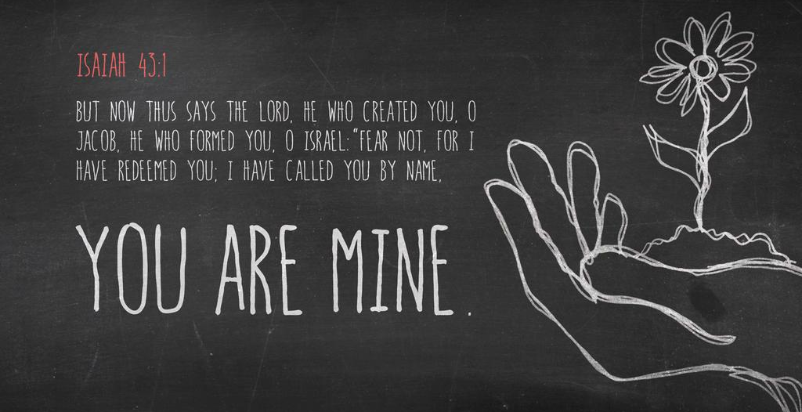
ever singing, ever praising,

one with all, and one with you.

“I Was There to Hear your Borning Cry”

ACT of Confession

The congregation responds with the text in BOLD PRINT

Prayer for Forgiveness Confession
(inspired from Isaiah 43, Psalm 29, Luke 3)
Creator of the universe,
we stand amazed at your power and glory.
Proclaimed by the prophets,
Sung in our hymns,
Echoing in our experiences of your beauty.
We are eager to worship you and offer our praise,
but all too often we are reluctant to answer
when we hear you calling our name.
We find our hearing
and capacity to process information
inundated by input, data, words and noise.
We struggle to unplug, to unwind, to be still.
As a society, we look to technological devices
in our pockets and on our desks,
to remind us of what we’ve forgotten,
to teach us what we haven’t learned,
to entertain us when we are bored,
to respond to our every whim.

For the ways
in which we seek to be over-programmed
instead of sitting with our boredom,
forgive us.
For the ways in which we flee the silence
in which you may speak to us,
heal us.
For the public and private spaces we’ve created
in which we are never still,
redeem us.
Quiet us,
that we might hear anew of your love
Remind us,
of the agency and responsibility, you’ve given us,
Rekindle in us the strength to proclaim your justice
through the world through the power
of your ever-present love.
Amen.

Author: John Ylvisaker, © 1985 John Ylvisaker

Tune: WATERLIFE Glory to God: Hymnal #488

1. “I was there to hear your borning cry

I’ll be there when you are old

I rejoiced the day you were baptized

To see your life unfold

I was there when you were but a child

With a faith to suit you well

In a blaze of light, you wandered off

To find where demons dwell.”

2. “When you heard the wonder of the word

I was there to cheer you on

You were raised to praise the living Lord

To whom you now belong

If you find someone to share your time

And you join your hearts as one

I’ll be there to make your verses rhyme

From dusk til rising sun.”

3. “In the middle ages of your life

Not too old, no longer young

I’ll be there to guide you through the night

Complete what I’ve begun

When the evening gently closes in

And you shut your weary eyes

I’ll be there as I have always been

With just one more surprise.”

4. “I was there to hear your borning cry

I’ll be there when you are old

I rejoiced the day you were baptized

To see your life unfold.”

“Ancient Words”
Lynn DeShazo

“Spirit, Spirit of Gentleness” continued…

2. You moved on the waters, you called to the deep,
then you coaxed up the mountains
from the valleys of sleep;
and over the eons you called to each thing;
“Awake from your slumbers and rise on your wings.”

3. You swept through the desert,
you stung with the sand
and you goaded your people with a law and a land;
and when they were blinded with idols and lies,
then you spoke through your prophets
to open their eyes.

4. You sang in a stable, you cried from a hill,
then you whispered in silence
when the whole world was still;
and down in the city you called once again,
when you blew through your people
on the rush of the wind.

5. You call from tomorrow,
you break ancient schemes.
From the bondage of sorrow
all the captives dream dreams;
our women see visions, our men clear their eyes.
With bold new decisions your people arise.

“Let Us Break Bread Together”

African-American spiritual

Blue Hymnal #513

1 Let us break bread together on our knees;
(on our knees;)
Let us break bread together on our knees.
(on our knees;)
When I fall on my knees,
With my face to the rising sun,
O Lord, have mercy on me. (on me.)

2. Let us drink wine together on our knees;
(on our knees;)
Let us drink wine together on our knees.
(on our knees;)…

3. Let us praise God together on our knees;
(on our knees;)
Let us praise God together on our knees.
(on our knees;)…

Lift Up Your Hearts: #762

- Holy words long preserved,
For our walk in this world
They resound with God’s own heart,
O let the ancient words impart
Words of life, Words of hope,
Give us strength, Help us cope
In this world where e’er we roam,
Ancient words will guide us home.

Chorus:
Ancient words ever true,
Changing me and changing you
We have come with open hearts,
O let the ancient words impart

Blessing/Assurance of Pardon
Hear the words of our creator,
spoken through the prophet Isaiah:
“I have called you by name.
You are mine. Do not fear,
for I have redeemed you.”

“Morning Has Broken”
Eleanor Farjeon (1931)
Tune: BUNESSAN | Blue Hymnal #469

1. Morning has broken, like the first morning
Blackbird has spoken, like the first bird
Praise for the singing, praise for the morning
Praise for them springing fresh from the word

2. Sweet the rain’s new fall, sunlit from heaven
Like the first dewfall on the first grass
Praise for the sweetness of the wet garden
Sprung in completeness where his feet pass

“Spirit, Spirit of Gentleness”

Author: James K. Manley (1975)

Tune: SPIRIT (Manley) Blue Hymnal #319

1 Spirit, spirit of gentleness,
blow through the wilderness, calling and free,
Spirit, spirit of restlessness,
stir me from placidness, wind, wind on the sea.

Continued in the next column…

