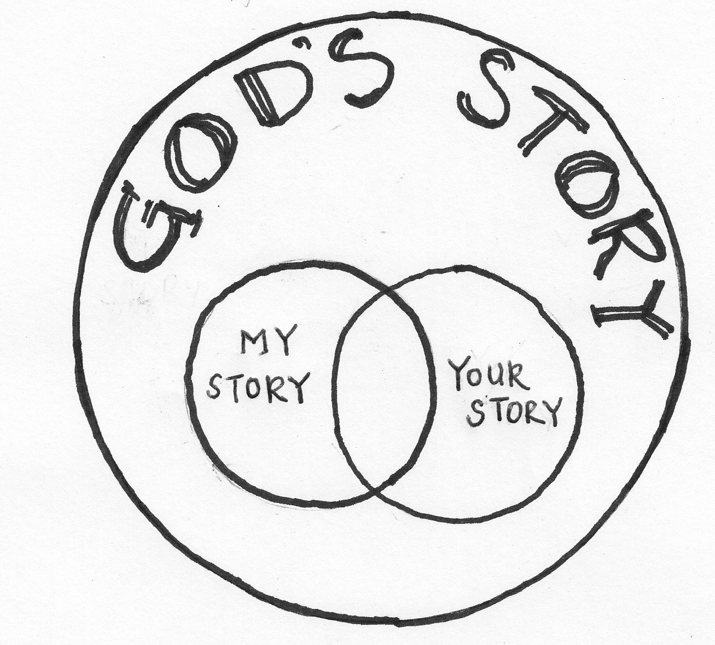
Good Friday

We’re worshipping by Zoom – During the service we’ll project the lyrics and readings on the screen share so that all can see them. Throughout the service everyone will be muted to ensure that we have good sound quality. Monte will unmuted each reader as the time necessitates.

The end of our service is a time of prayer in which we name the brokenness in and of our world. You’re invited to share your prayers via the Chat option. On the bottom center menu bar.

Today is the day that we remember and retell the crucifixion and death of Jesus of Nazareth. A great proclaimed theological mystery. God – who is by divine essence, life itself – dies. And that death gives life, like a seed, to all appearances dead, planted in the ground.

So why do we call it good?

The word “good” previously meant “pious” or “holy.” It is good in the sense that it is a holy. A wholly mysterious, day. It is good, theologically speaking, for the horror of the cross proclaims the hope in a God who is infinitely close to us. A God who knows the deepest pains

retelling the story at the heart of all of our stories

Prelude
We are gathered as a community by our common hope in Jesus the Christ

Gathering Song: “Wondrous Love” - insert

Call to Worship: Lord, where are you now?

Song of Repentance: “When I Survey The Wondrous Cross” (Blue Hymnal #100)

Entering into the Sacred Story through Readings of Scripture & Song:
Reading 1 Elaine Price
Mark 8:22-35

Extinction of a Candle | Silent Reflection

“Lord Why Have You Forsaken Me?” (Purple Hymnal #210, v. 1 )

Reading 2 Rev. Karl Shadley
Mark 14:10-26

Extinction of a Candle | Silent Reflection

“Lord Why Have You Forsaken Me?” (Purple Hymnal #210, v. 2)

Reading 3 Anne Marie Adams
Mark 14:27-42

Extinction of a Candle | Silent Reflection

“Lord Why Have You Forsaken Me?” (Purple Hymnal #210, v. 3)

Reading 4 Louise Hirschman
Mark 14:43-65

Extinction of a Candle | Silent Reflection

“Lord Why Have You Forsaken Me?” (Purple Hymnal #210, v. 4)

Reading 5 Cristina Ramirez Fonua
Mark 14:66-15:15

Extinction of a Candle | Silent Reflection

“Were You There When They Crucified My Lord?” (Purple Hymnal #228, v. 1)
Reading 6 Mike Evans
Mark 15:16-32

Extinction of a Candle | Silent Reflection

“Were You There When They Crucified My Lord?” (Purple Hymnal #228, v. 2 & 3)
Reading 7 Bob Brylawski
Mark 15:33-47
and suffering of the human condition, and actively sides with creation, working for universal liberation and healing.

Therefore, nothing can separate us from God. For God has not let anything separate us from him.

When was the crucifixion?
Based on the details of the Gospels & other historical texts, the Crucifixion of Jesus was most probably on a Friday in early April of 33 or 34 ce.

Crucifixion is an ancient method of execution in which the condemned person is affixed to a large wooden cross (of various shapes) and left to hang until dead. It was the preferred form of capital punishment for criminals and enemies of the state during the Roman Empire until Emperor Constantine abolished it in 337 CE.

Crucifixion was often performed to terrorize and dissuade the onlookers from perpetrating the crimes punishable by it. Victims were left on display after death, as warnings so that others who attempt dissent might be controlled. Crucifixion was usually intended to provide a death that was particularly slow, painful, gruesome, humiliating, and public, using whatever means were most expedient for that goal.

It is a poignant paradox that Jesus dies this most horrific and public of deaths when he was such a public teacher of nonviolence and spiritual renewal.

What invitation does this story of the death of God and the execution of the author of nonviolence carry for the way we live today in the East Bay?

Extinction of a Candle | Silent Reflection

“Were You There When They Crucified My Lord?” (Purple Hymnal #228, v. 4 & 5)

laying down our burdens and brokenness – experiencing the mercy and mystery of repentance as we prayer for the world

Traditionally we carry the large cross that we place in the sanctuary from our inside space to the public square in our garden. This passage in a re-presentation of the death of Jesus in the public square – the declaration that God is in the darkness, brokenness and death that populate our world. As we gather around the cross we share our prayers for spaces and places were we see the power of death and ask for God’s resurrection love to overcome, liberate and heal. You’re invited to share your prayer requests in the chat using the chat function in the Zoom software. The liturgist will then share each prayer request, closing it with God in your mercy. You’re invited to respond with “hear our prayer” wherever you may be. We’ll close that prayer for the world with the Lord’s prayer.

Sending Song: “Amazing Grace” (Blue Hymnal #107)

Sending Blessing

College Avenue Presbyterian Church
5951 College Avenue | Oakland | 94618 | www.capcoakland.org
safe | open | real

join us easter morning at 10:30am on our zoom channel

Walking the Way (excerpt from the book by John Dear)

“God in Jesus shows us the heights of nonviolence. He shows us how to be human even in the face of the greatest inhumanity. He shows us how to be Godly.

Jesus is stripped of the purple garments, given his clothes bac, led through Jerusalem, taken to the garbage dump outside the city walls, and crucified with two men who had murdered Roman soldiers to spark the revolution. Jesus is killed as if he too were a violent revolutionary. So, besides being tortured and executed, he is completely misunderstood. He has been betrayed, denied, and abandoned by all his friends, and no one knows who he is, what he has done, or where he has come from. He undergoes his brutal suffering all alone.

All he has left is the God who first called him “my beloved.” I think there on the cross, Jesus turned inward and clung to God as a child to a loving parent, knowing that soon it would be over ad he would be with his loving God. It is that faith, trust, and intimate love that enabled Jesus to practice perfect nonviolence unto death. This is the nonviolence he calls us to practice as well. He wants us to go as deep into nonviolence as we can, even until our own deaths, that we might follow him completely and share in his friendship and peace.”

Lyrics & WRITTEN RESPONSES FOR TODAY’S celebration

“What Wondrous Love Is This”
American Folk Hymn (1811) Glory to God Hymnal #215

- What wondrous love is this o my soul, o my soul
What wondrous love is this o my soul
What wondrous love is this that cause the lord of bliss
To bear the dreadful curse for my soul, for my soul
To bear the dreadful curse for my soul

- When I was sinking down, sinking down, sinking down
When I was sinking down, sinking down
When I was sinking down, beneath God’s righteous frown
Christ laid aside his crown for my soul, for my soul
Christ laid aside his crown for my soul

- To God and to the lamb I will sing I will sing
To God and to the lamb I will sing
To God and to the lamb, who is the great “I Am”
While millions join the theme I will sing, I will sing
While millions join the them I will sing

- And when from death I’m free, I’ll sing on, I’ll sing on And
when from death I’m free, I’ll sing on And
when from death I’m free, I’ll sing and joyful be And
through eternity I’ll sing on, I’ll sing on And
through eternity I’ll sing on.

Call to Worship: “Lord where are you now?”
Written by Monte, inspired by a text from the Iona Community.

One: So here we are on the Friday we call Good,
when the Human One who lived so radically for others
was killed for that generosity.
All: Lord, where are you now?

One: We turn to the story of the Cross the rejection of Jesus by all
Because of fear of too much love,
of including too many,
of being seen as against the status quo
All: Lord, where are you now?

One: In retelling the story we enter into it,
Recognizing that Jesus was abandoned,
rejected, forgotten and suffered
All: Lord, where are you now?

One: We enter into the story anew today as we face
Great social isolation, feeling abandoned,
Seeing how some around us are forgotten,
Suffering in the midst of a pandemic
that can seem like darkness with no end in sight.
All: Lord, where are you now?

One: We come to the cross – the space and symbol
In which we taste the radical solidarity,
The liberating love and
Contagious grace of God.
All: Lord, open our eyes
that we might see where you are right now.

“When I Survey the Wondrous Cross”
Isaac Watts (1707) | Blue Hymnal #100

- When I survey the wondrous cross
On which the Prince of glory died,
My richest gain I count but loss,
And pour contempt on all my pride.

2 Forbid it, Lord, that I should boast,
Save in the death of Christ my God;
All the vain things that charm me most,
I sacrifice them to His blood.

3 See, from His head, His hands, His feet,
Sorrow and love flow mingled down;
Did e’er such love and sorrow meet,
Or thorns compose so rich a crown?

4 Were the whole realm of nature mine,
That were a present far too small;
Love so amazing, so divine,
Demands my soul, my life, my all.

“Lord, Why Have You Forsaken Me (Psalm 22)”
Christopher Webber (1986; alt.)
Glory to God #210

- Lord, why have you forsaken me,
and why are you so far away
from my complaint and my distress
poured out before you night and day?

2. Yet you are holy, and the songs
of praise of Israel are your throne;
when our ancestors called on you,
you saved them, rescued all your own.

3. But I am mocked and put to scorn.
All those who see me laugh and say,
“You trust in God, so let us see
the help of God to whom you pray.”

4. Yet you, O Lord, have been my God
and only hope since I was born.
With trouble near me, none can help.
My Savior, leave me not forlorn.

“Where You There”
African American spiritual | Glory to God #228

- Were you there when they crucified my Lord? (Were you there?)
Were you there when they crucified my Lord?
O! Sometimes it causes me to tremble, tremble, tremble.
Were you there when they crucified my Lord? (Were you there?)

2 Were you there when they nailed him to the tree? (Were you there?)
Were you there when they nailed him to the tree?
O! Sometimes it causes me to tremble, tremble, tremble.
Were you there when they nailed him to the tree? (Were you there?)

3 Were you there when they pierced him in the side? (Were you there?)
Were you there when they pierced him in the side?
O! Sometimes it causes me to tremble, tremble, tremble.
Were you there when they pierced him in the side? (Were you there?)

4 Were you there when the sun refused to shine? (Were you there?)
Were you there when the sun refused to shine?
O! Sometimes it causes me to tremble, tremble, tremble.
Were you there when the sun refused to shine? (Were you there?)

5 Were you there when they laid him in the tomb? (Were you there?)
Were you there when they laid him in the tomb?
O! Sometimes it causes me to tremble, tremble, tremble.
Were you there when they laid him in the tomb? (Were you there?)

“Amazing grace!
John Newton (1779) Blue Hymnal #107

1 Amazing grace, how sweet the sound,
That saved a wretch like me!
I once was lost, but now am found,
Was blind, but now I see.

2 ’Twas grace that taught my heart to fear,
And grace my fears relieved;
How precious did that grace appear
The hour I first believed!

3 Through many dangers, toils and snares,
I have already come;
’Tis grace hath brought me safe thus far,
And grace will lead me home.

4 The Lord has promised good to me,
His Word my hope secures;
He will my shield and portion be
As long as life endures.

5 When we’ve been there ten thousand years,
Bright shining as the sun,
We’ve no less days to sing God’s praise
Than when we’d first begun.

